This project has taught me a lot more about GUI’s and how useful they really can be! One of the biggest things I have learned from this week's project is to keep my code organized properly so you can pinpoint errors easy and efficiently. I have added comments to nearly everything that was being added to the program so anyone who reads my code should be able to fully understand everything without much trouble. This was actually the first time I have written to a CSV file for excel before and it seemed to work out pretty well, there is so much you can do in java that I don’t know about! In my sequence file the *computeIterative* and *computeRecursive* methods were a lot of trial and error with getting the correct output to display but I finally got it working properly, this was probably the hardest part of the project. Overall this project was definitely a nice refresher in GUI’s, I actually love dealing with GUI’s and coding them, it is what I want to try and do as a job once I graduate from UMUC. Thanks again for all the help!

UML (I also added this in the project 3 folder submission.):

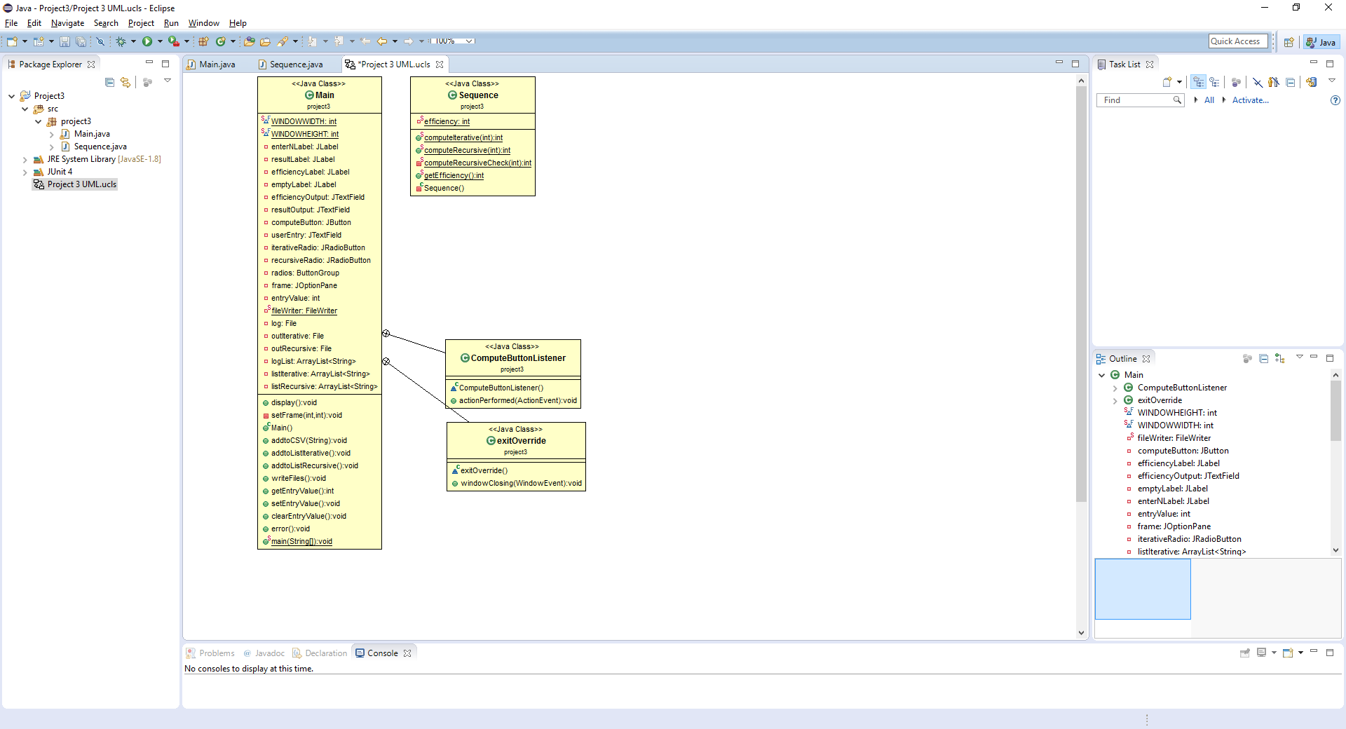

Test Plan:

The user interface presented to the user at program execution:

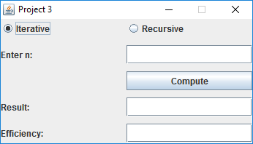

The error displayed to the user when entering a negative number, letter or number not between -1 and 11.

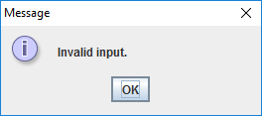

Both cases below would cause the error above to display when you click the “Compute” button.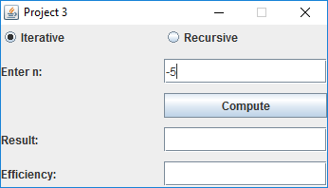

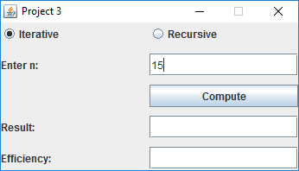

Entering the number 6 in the “Enter n:” field with the Iterative radio button selected shows the following result and efficiency output to the user.

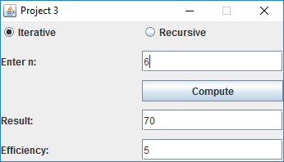

Entering the number 6 in the “Enter n:” field with the Recursive radio button selected shows the following result and efficiency output to the user.

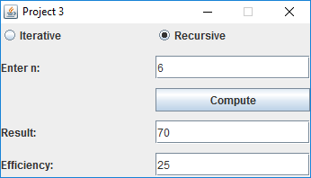

Once the GUI is closed by the user, the following files will be created:

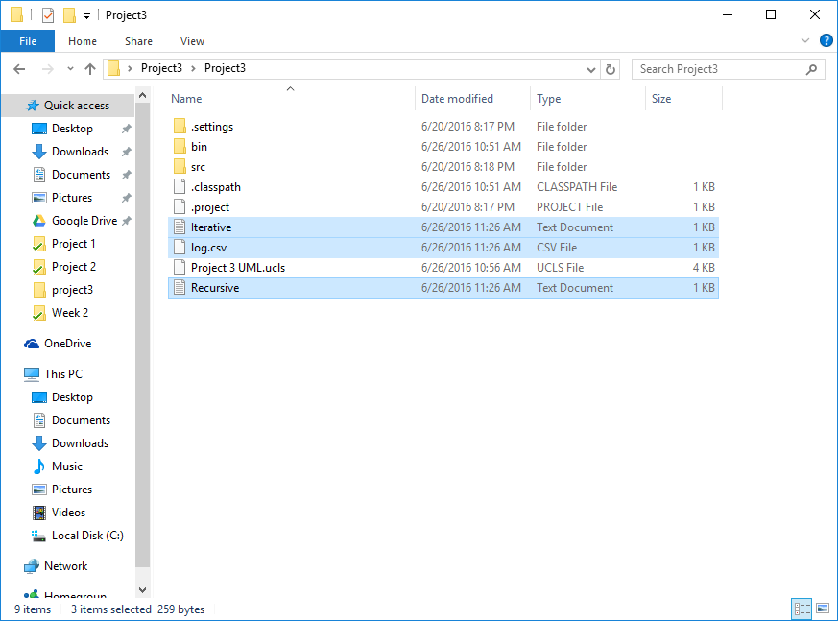

Iterative.txt:

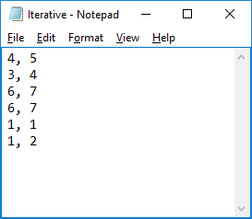

Recursive.txt:

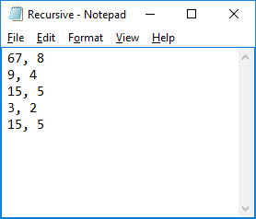

Log.csv:

I do not have excel on my computer so I used google spreadsheets instead, hope this is ok!

